#### **1. What is the result of the code, and explain?**

>>> X = 'iNeuron'

>>> def func():

print(X)

>>> func()

**Ans:** The Result of this code is iNeuron, it's because the function initially looks for the variable X in its local scope,But since there is no local variable X, its returns the value of global variable x ie iNeuron

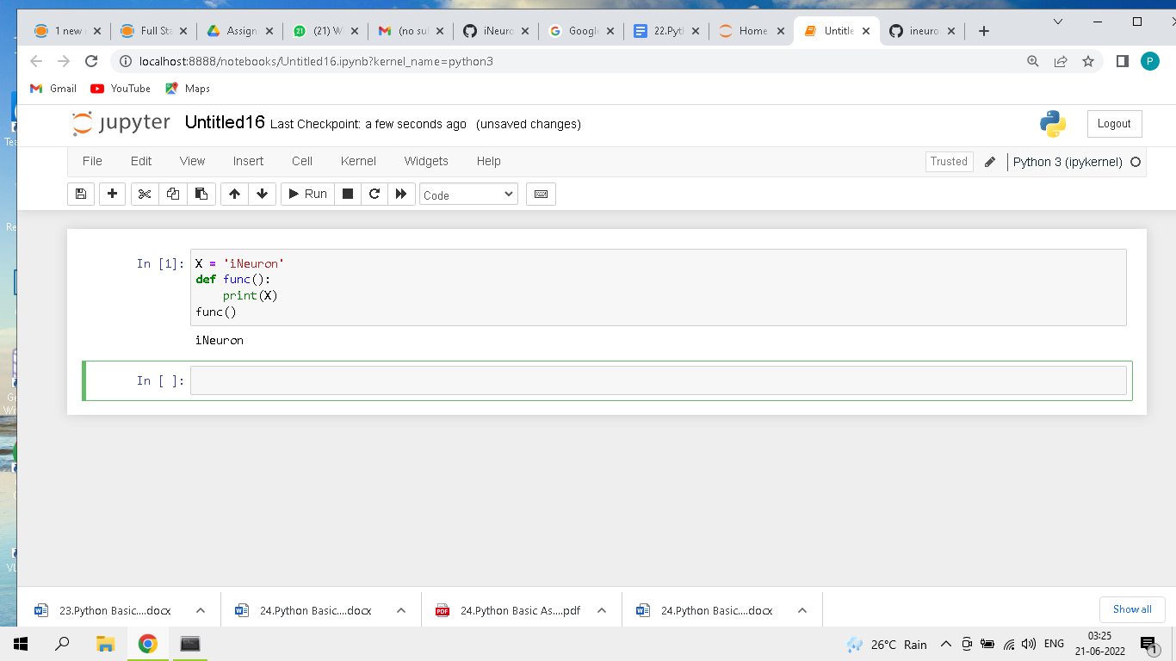

#### **2. What is the result of the code, and explain?**

>>> X = 'iNeuron'

>>> def func():

X = 'NI!'

>>> func()

>>> print(X)

**Ans:** The Result of this code is NI!, because the function initially looks for the variable X in its local scope if X is not available then it checks for variable X in the global scope, Since here the X is present in the local scope. it prints the value NI!

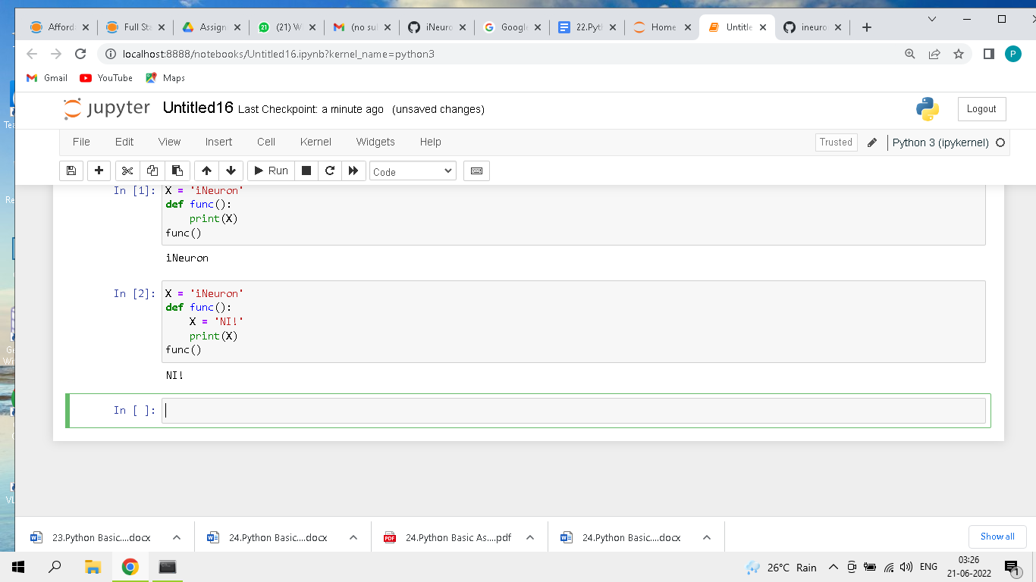

#### **3. What does this code print, and why?**

>>> X = 'iNeuron'

>>> def func():

X = 'NI'

print(X)

>>> func()

>>> print(X)

**Ans:** The output of the code is NI and iNeuron. X=NI is in the local scope of the function func() hence the function prints the x value as NI. X = 'iNeuron' is in the global scope. hence print(X) prints output as iNeuron

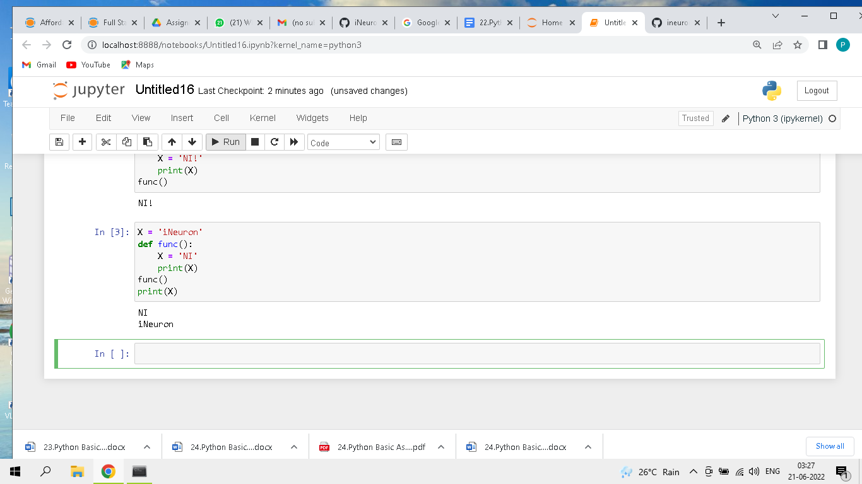

#### **4. What output does this code produce? Why?**

>>> X = 'iNeuron'

>>> def func():

global X

X = 'NI'

>>> func()

>>> print(X)

**Ans:** The output of the code is NI. the global keyword allows a variable to be accessible in the current scope. since we are using global keyword inside the function func it directly access the variable in X in global scope. and changes its value to NI. hence the output of the code is NI

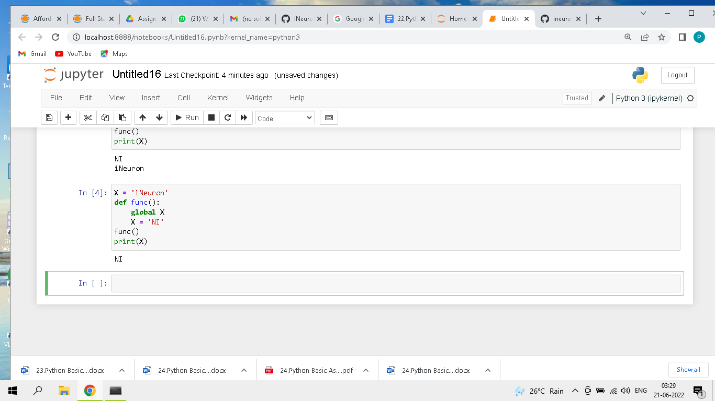

#### **5. What about this code—what’s the output, and why?**

>>> X = 'iNeuron'

>>> def func():

X = 'NI'

def nested():

print(X)

nested()

>>> func()

>>> X

**Ans:** The output of the code is NI. The reason for this output is if a function wants to access a variable, if it's not available in its localscope. it looks for the variable in its global scope. similarly here also function nested looks for variable X in its global scope. hence the output of the code is NI

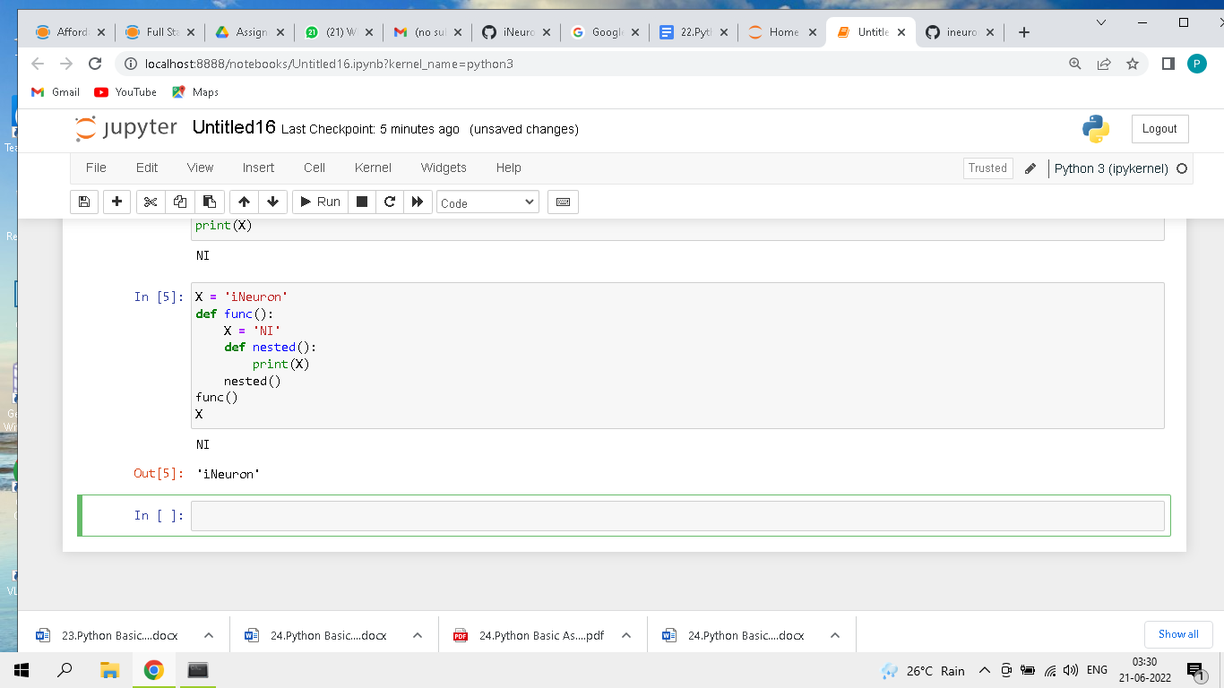

#### **6. How about this code: what is its output in Python 3, and explain?**

>>> def func():

X = 'NI'

def nested():

nonlocal X

X = 'Spam'

nested()

print(X)

>>> func()

**Ans:** The output of the code is Spam. a nonlocal keyword in python is used to declare a variable as not local.Hence the statement X = "Spam" is modified in the global scope. hence the output of print(X) statement is Spam

